Problem Statement: To develop a software that would provide five types of insurance services, namely; life, medical, motor, home, and travel. The details can be viewed and updated by the officials of the company

Objectives:

1. User should be able to view various policies and schemes of the insurance company
2. New users can register on the site
3. An existing policy holder can view his details and calculate premium
4. The website would provide details about new strategies and subsidiary schemes
5. Administrator will approve new users
6. Users will be sent pdf statements to their mail accounts

Process Model Identification:

We have decided to use Spiral model for our project on Insurance and Tracking system. We have chosen it due to the following reasons

1. This model will allow us to identify and solve sub-problems with highest risk first. For e.g. During transaction processing, entering of credit card number and its validation will be solved and checked first
2. Flexibility is offered in this model. We have the advantage of waterfall as well as Rapid Prototyping methods. For e.g. If new modes of payment get introduced apart from credit card such as net banking by a particular bank, then that can be incorporated in our system
3. Provides good comprehensive coverage of all features
4. Risk management is available in this model. We need this because heavy amounts of user data and money is at stake in the transaction process. And this model provides many checks to ensure a safe and reliable transfer and sharing of information and services.

Deliverables:

1. Display all policies to users
2. Register for any new policy and payment online
3. Track policy changes and get updated with stocks
4. Option to surrender a policy at any time and get back dues
5. Customer complaint service availability

## Gantt chart For Project

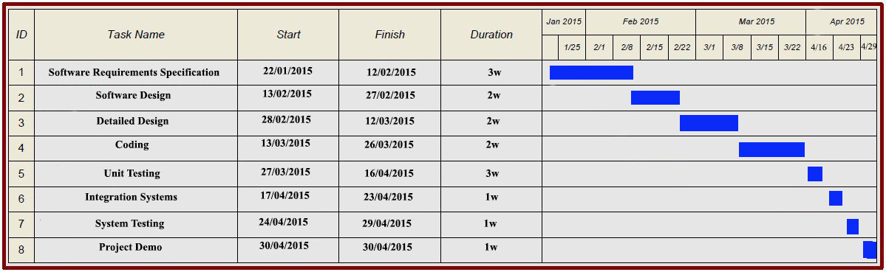

## PERT Chart for Project

## pert

**Project Time Line Chart**

